**PROJECT REPORT TEMPLATE**

**TAMILAVEL UMAMAHESWARANAR KARANTHAI ARTS COLLEGE , THANJAVUR-2.**

**DEPARTMENT OF MATHEMATICS**

**UNVELLING MARKET INSIGHTS:ANALYSING SPENDING BEHAVIOUR AND IDENTIFYING FOR GROWTH**

Faculty mentor: Mrs.P.Annegoodwin M.Sc., B.Ed.,

**PROJECT DONE BY**

Sujithra R - Team leader

Elavarasi M - Team member

Divyadharshini K - Team member

Vasanthakumari R - Team member

Sivaranjini R - Team member

INTRODUCTION:

**Unveiling Market Insights: Analysing Spending Behaviour and Identifying Opportunities for Growth. Creating Dashboard, Story using Tableau and analyzing Spending Behaviour and Identifying Opportunities for Growth. he consumption and production of marketed food are spatially separated. Production is primarily in rural areas while consumption is mainly in urban areas.In today's highly competitive business landscape, gaining deep market insights is essential for businesses to thrive and grow. This project aims to analyze customer spending behavior and identify opportunities for growth by leveraging data analytics and data-driven decision-making.**

**Purpose:**

**Market research analysis plays a crucial role in helping businesses make informed decisions, identify opportunities, and mitigate risks. By extracting valuable insights from data, businesses can develop effective strategies, refine their products or services, and ultimately drive growth**

**EMPATHYMAP:**

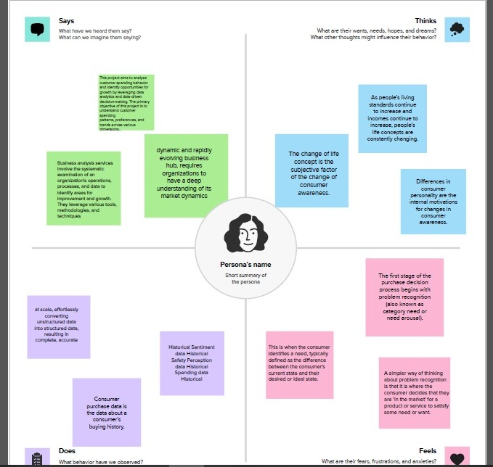

**BRAINSTROME:**

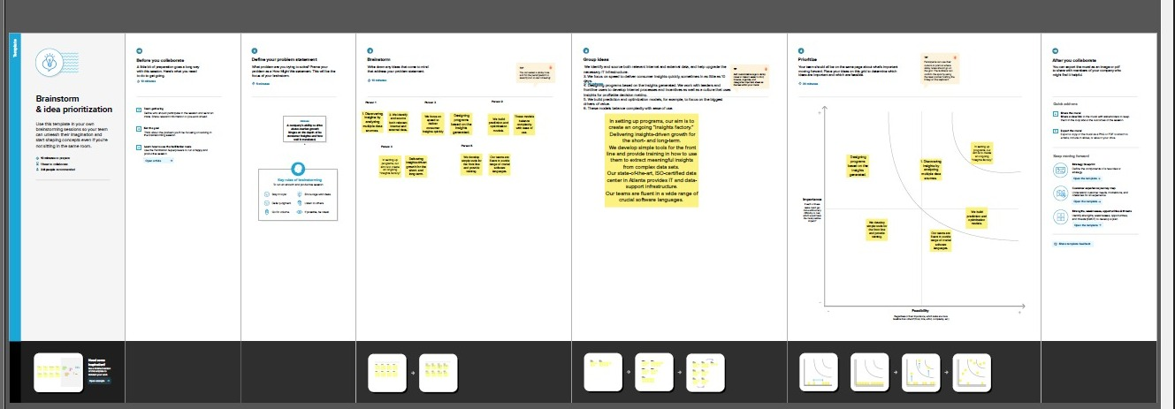

**SHEET 1:**

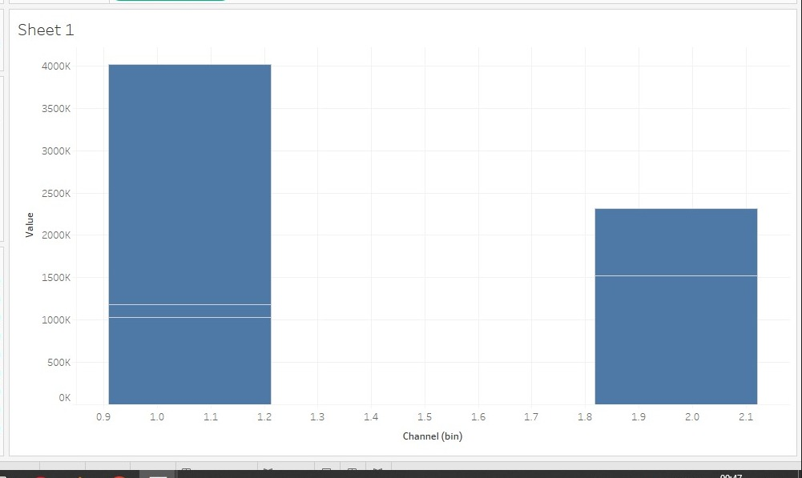

SHEET 2  
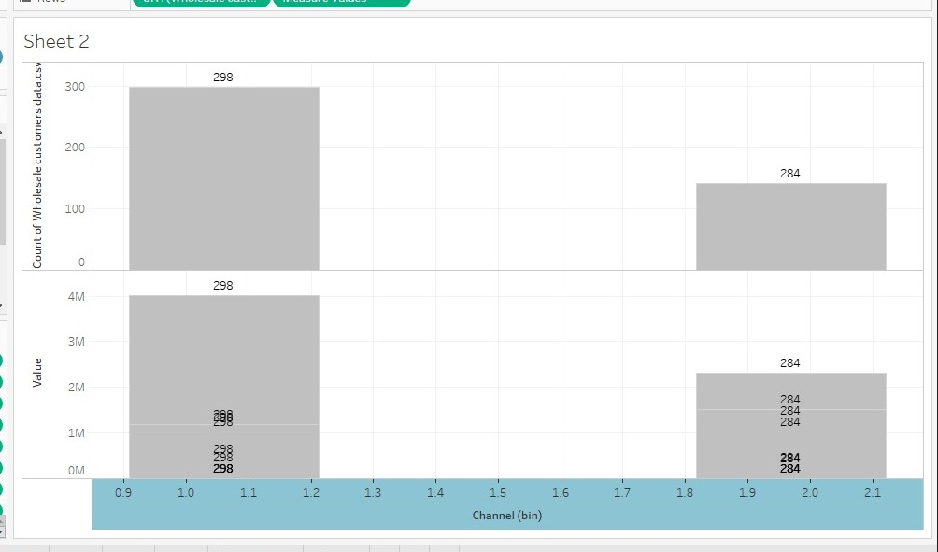

SHEET 3

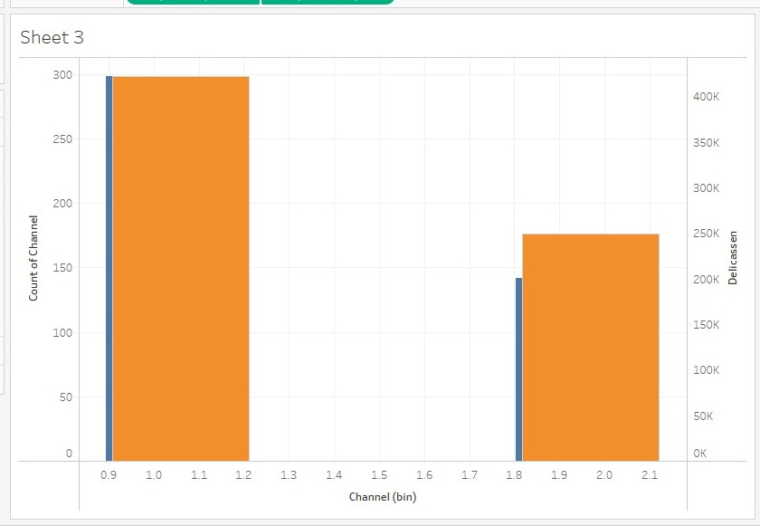

STORY:

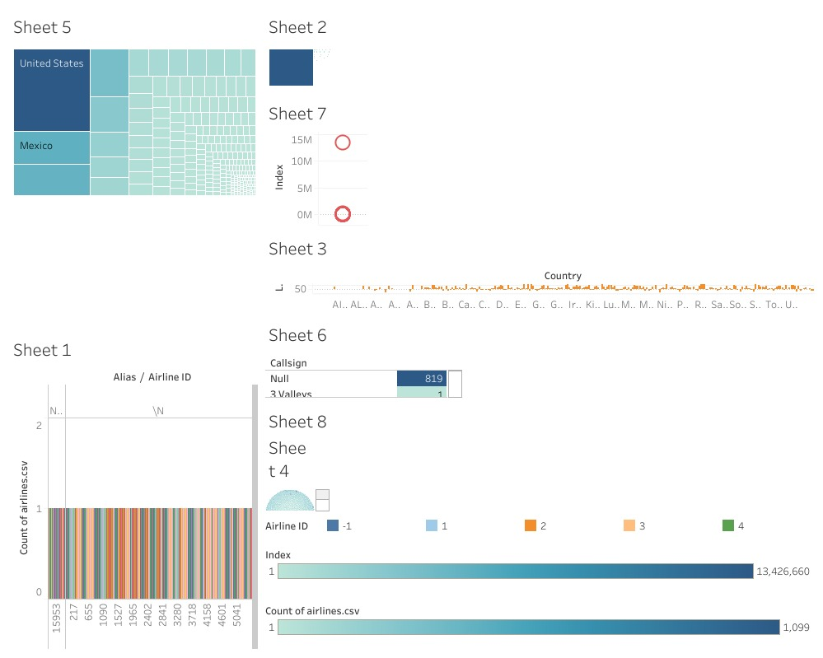

DASHBORD

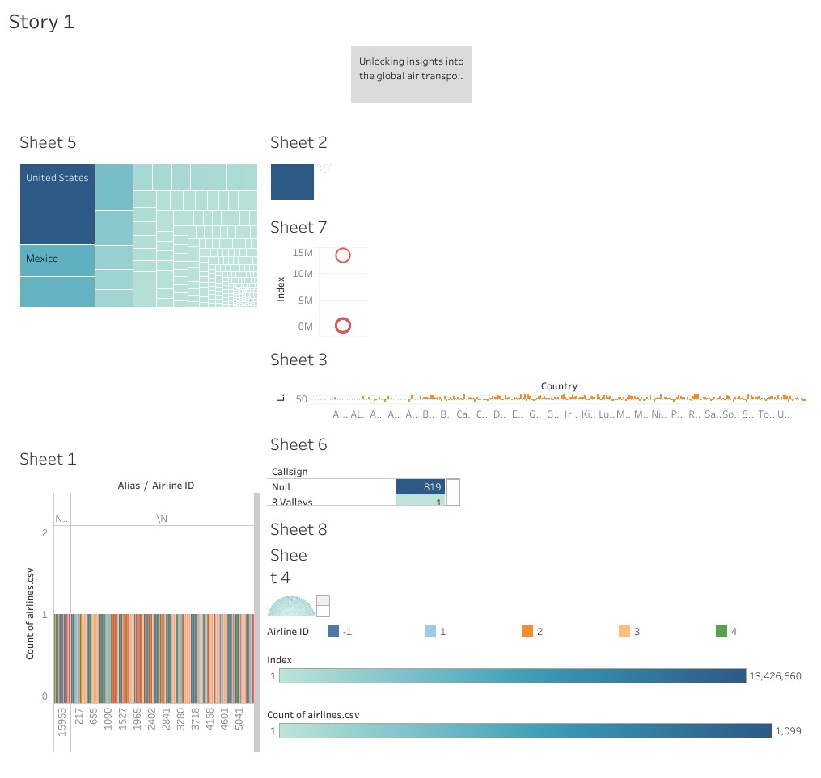

Advantages:

It helps businesses

strengthen their position. ...

It minimises any investment risk. ...

It identifies potential threats and opportunities. ...

It helps to discover your's and your competitor's strengths and weaknesses. ...

It facilitates strategic planning. ...

It helps in spotting emerging trends.

Disadvantages

Respondents may not feel encouraged to provide accurate, honest answers.

Respondents may not feel comfortable providing answers that present themselves in a unfavorable manner.

Respondents may not be fully aware of their reasons for any given answer because of lack of memory on the subject, or even boredom.

APPLICATION

1)The importance of air transport lies in its ability as an economic engine to generate and support jobs, strengthen trade and connectivity between people and countries, promote tourism, and connect remote communities This project aims to analyze customer spending behavior and identify opportunities for growth by leveraging data analytics and data-driven decision-making.

CONCLUSION

The primary objective of this project is to understand customer spending patterns, preferences, and trends across various dimensions.. By conducting a comprehensive analysis, businesses can optimize their marketing strategies, improve product offerings, and enhance customer engagement to drive revenue growth

FUTURE SCOPE

The industry has a number of domestic and international airlines, as well as a large network of airports. The future of the aviation industry in India is likely to see continued growth and expansion, driven by factors such as a growing middle class, increased tourism, and government policies supporting the industry